Create Node-RED Service

|  |  |
| --- | --- |
| **Team ID** | PNT2022TMID02412 |
| **Project Name** | GAS LEAKAGE MONITORING AND ALERTING SYSTEM FOR INDUSTRIES |
| **Team members** | Gowthamkumar  Lakshmi viyamesh  Hariprasad  Bharath Kumar |

# Aim:

To create a web application, create a Node-RED service.

# Steps to be followed

**Step 1:** Navigated to the App creation page.

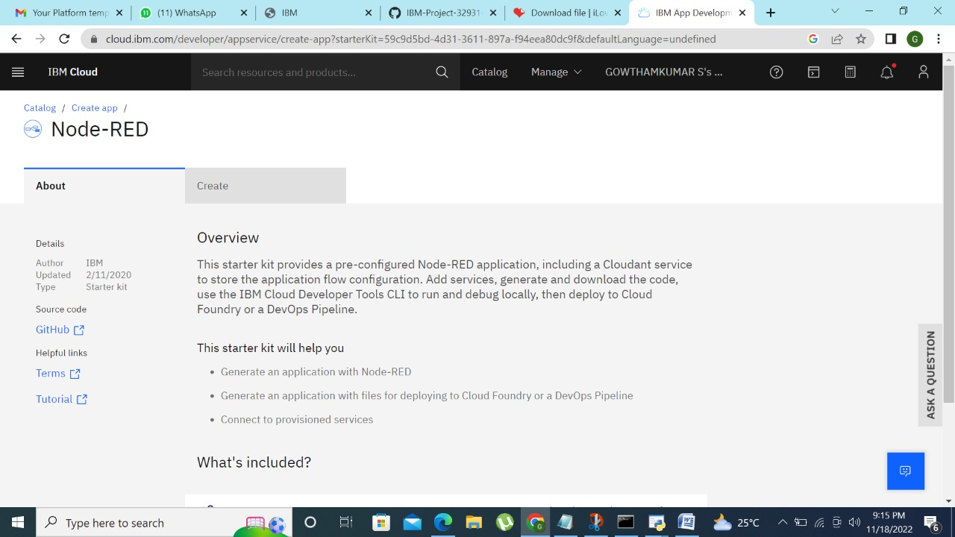

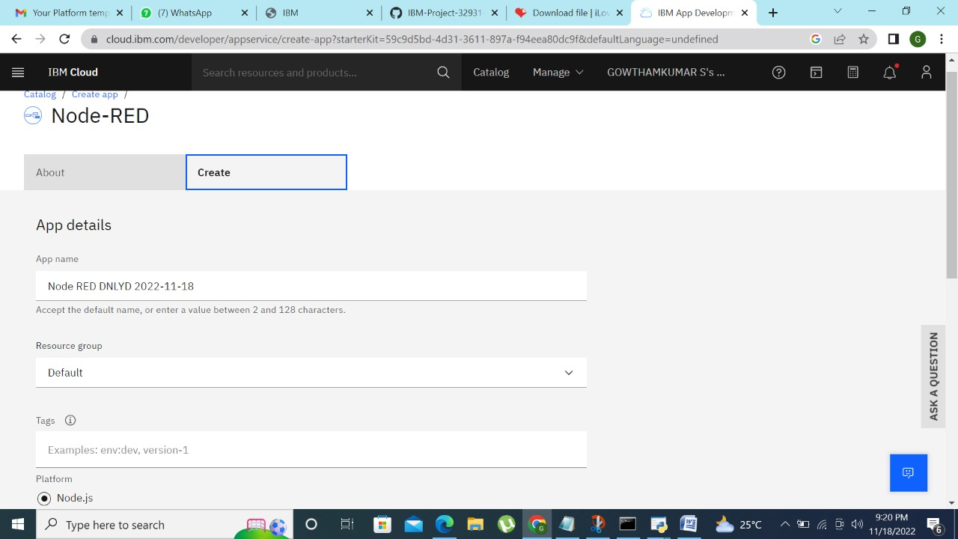

**Step 3:** Clicking on the “Deploy your App” Button.

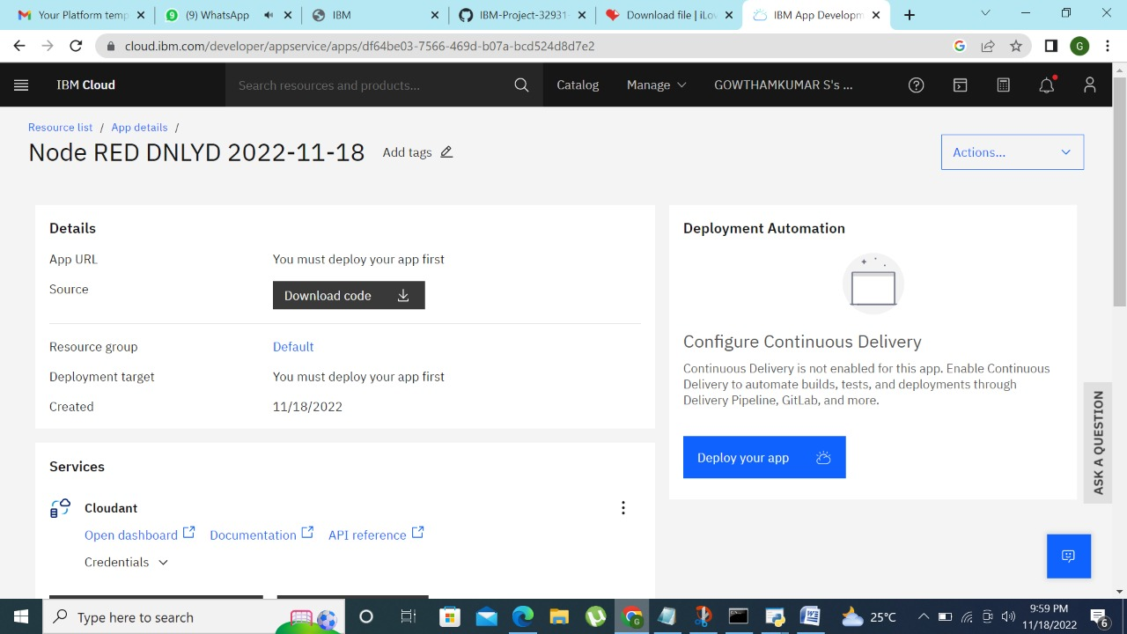

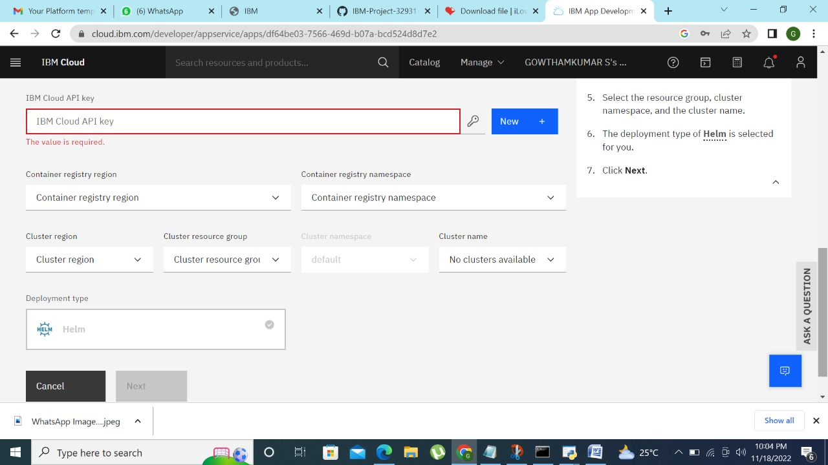

***Step 5:*** *Successfully deployed the app.*

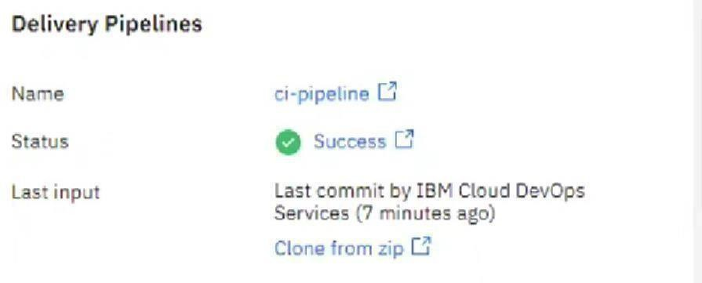

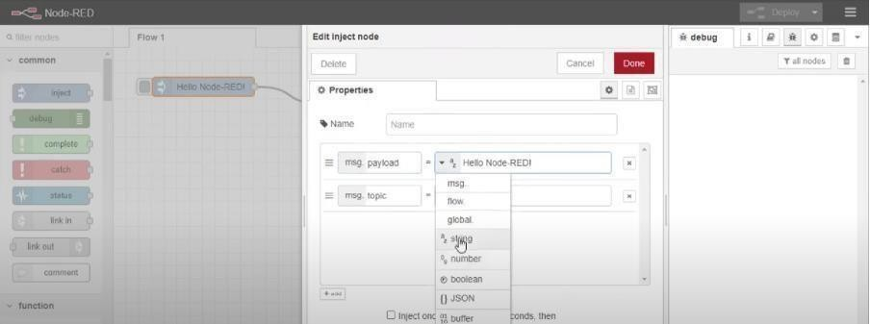

**Step 7**: Editing some values of the properties.

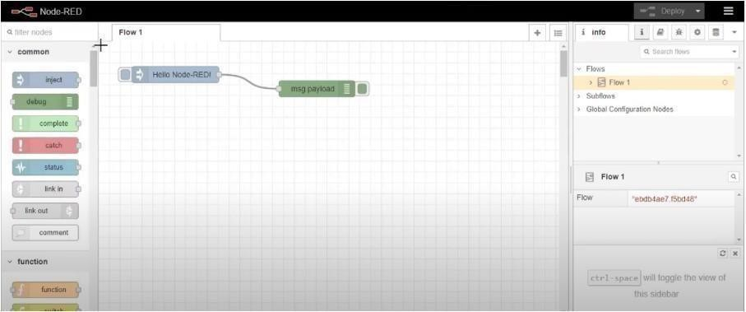

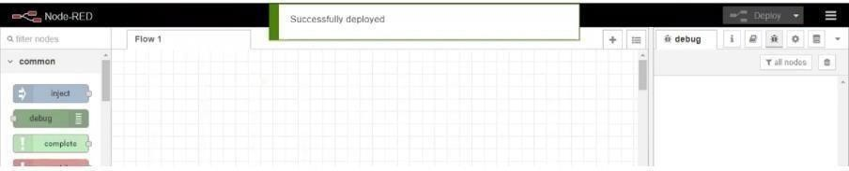

# Result:

Successfully created a Node RED service on IBM Cloud.